Team members :-

1. H.SOWMYA – 187Y1A04G6
2. S.SAI KUMAR – 187Y1A04G2
3. P.SHIVANI – 187Y1A04B0
4. N.VENKAT RAO – 187Y1A0453

RIVER WATER QUALITY MONITORING

Water is an important natural resource which needs constant quality monitoring for ensuring its safe use. This paper introduces a river water quality monitoring system based on wireless sensor network which helps in continuous and remote monitoring of the water quality data. The wireless sensor node in the system is designed for monitoring the turbidity,temperature of water,which is one of the main parameters that affect the quality of water. The proposed sensor node design mainly comprises of a signal conditioning module, processing module, wireless communication module and the power module. The sensed values will be wirelessly transmitted to the base station using IBM watson communication after the required signal conditioning and processing techniques. The circuit for the sensor node is designed, simulated and the hardware prototype is developed using the appropriate components which minimize the power requirement of the system and provides a cost effective platformfor monitoring water quality.

**INTRODUCTION :-**

India is a country in which many of the rivers are considered to be holy, but water pollution in India has greatly affected the sanctity of these rivers. Apart from that, the pollution of the water bodies has reached such an extent which has made many of the rivers too undesirable to use. Many rivers have been deemed to be unsafe for human consumption and this leads to water scarcity. It has been estimated that water pollution is the leading worldwide cause of deaths and diseases and it accounts for the deaths of more than 14,000 people daily. Water pollution in India affects the children more severely than any age of five die every year from diarrhea in India as a direct result of water related diseases. So there need to be a continuous check on the pollution of various water bodies in order to control them. All these facts demand the need for constantly monitoring the water quality of the various water bodies so that it helps in evaluating the extent of pollution control needed. Water quality monitoring also helps in characterizing and identifying the changes in water quality over time.

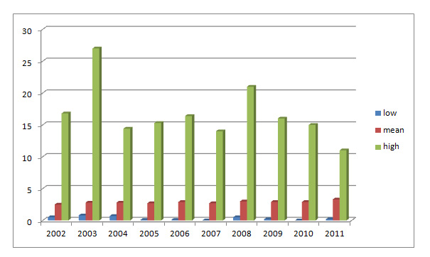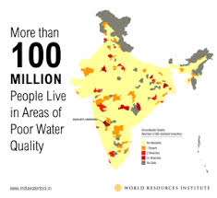

**HARDWARES USED IN THIS PROJECT :-**

**1.NODEMCU**

**2.TEMPERATURE SENSOR**

**3.TURBIDITY SENSOR**

**1.NODEMCU :-**

**NodeMCU** is an open source [IoT](https://en.wikipedia.org/wiki/Internet_of_Things" \o "Internet of Things) platform. It includes [firmware](https://en.wikipedia.org/wiki/Firmware) which runs on the [ESP8266](https://en.wikipedia.org/wiki/ESP8266) [Wi-Fi](https://en.wikipedia.org/wiki/Wi-Fi) [SoC](https://en.wikipedia.org/wiki/System_on_a_chip" \o "System on a chip) from [Espressif Systems](https://en.wikipedia.org/w/index.php?title=Espressif_Systems&action=edit&redlink=1" \o "Espressif Systems (page does not exist)), and hardware which is based on the ESP-12 module.The term "NodeMCU" by default refers to the firmware rather than the development kits. p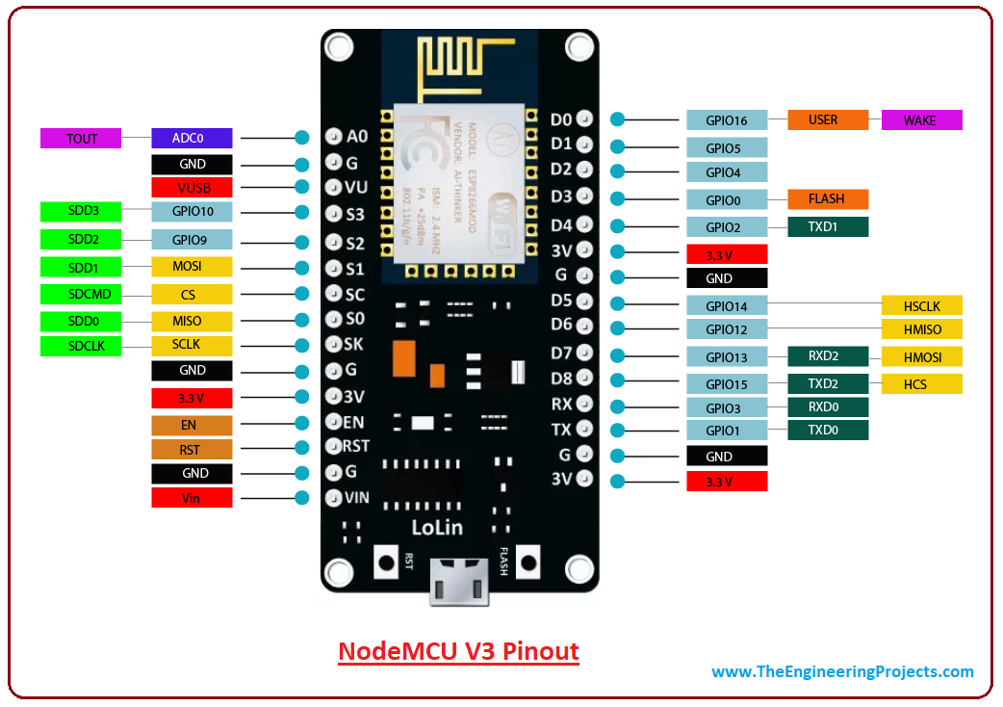

**2.Temperature sensor :-**

**Water Temperature indicates how water is hot or cold. The range of DS18B20 temperature sensor is -55 to +125 °C. This temperature sensor is digital type which gives accurate reading. Temperature is the most-measured process variable in industrial automation. Most commonly, a temperature sensor is used to convert temperature value to an electrical value. ... With the help of conditioning circuits, the sensor will reflect the change of environmental temperature.**

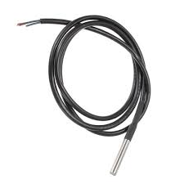

**3.Turbidity sensor :-**

**Turbidity is a measure of the cloudiness of water. Turbidity has indicated the degree at which the water loses its transparency. It is considered as a good measure of the quality of water. Turbidity blocks out the light needed by submerged aquatic vegetation. It also can raise surface water temperatures above normal because suspended particles near the surface facilitate the absorption of heat from sunlight.**

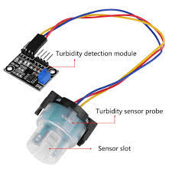

**SOFTWARES USED IN THIS PROJECT :-**

**1.ARDUINO IDE**

**2.MIT APP INVENTOR**

**3.IBM Watson**

**1.Arduino IDE :-**

**Arduino IDE is an open source software that is mainly used for writing and compiling the code into the Arduino Module.**

**It is an official Arduino software, making code compilation too easy that even a common person with no prior technical knowledge can get their feet wet with the learning process.**

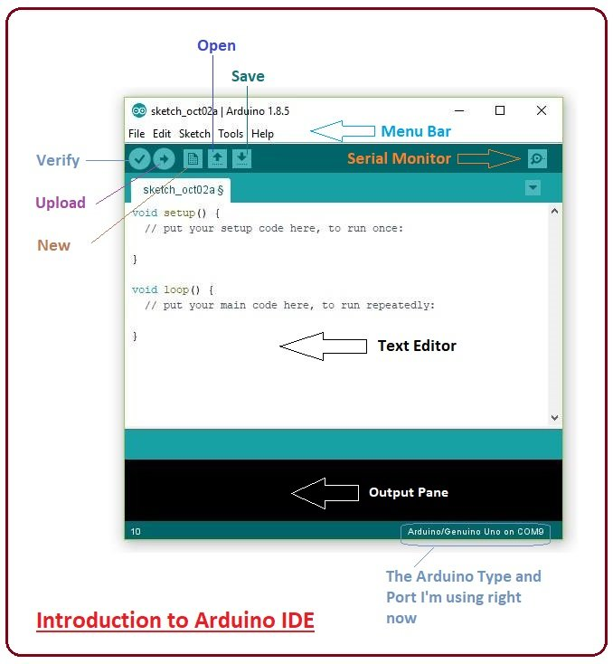

**2.MIT APP Inventor :-**

**MIT App Inventor is an intuitive, visual programming environment that allows everyone – even children – to build fully functional apps for smartphones and tablets. Those new to MIT App Inventor can have a simple first app up and running in less than 30 minutes.**

**3.IBM Watson :-**

**Watson is a question-answering computer system capable of answering questions posed in natural language, developed in IBM's DeepQA project by a research team led by principal investigator David Ferrucci. Watson was named after IBM's first CEO, industrialist Thom as J. Watson**.



# ALERT SYETEM & COMMUNICATION

After data is been measured, if any parameter doesn’t goes right then microcontroller sends an attention command to supervisor via GSM module. In addition to that particular parameter all other parameter values are also sends so that very little deflection in other sensor can be supervised. show flow chart of the complete process.

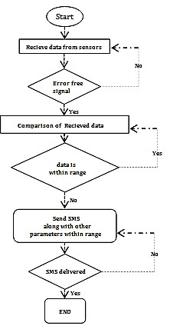

Flow chart

# NEED OF THE SYSTEM

In 21st century population growth is very high. Very few people getting pure drinking water but most of people not get pure drinking water,this is big problem in today’s situations. In a system there are different sensor used to detect water quality therefore easily understand which area supplying water is pure and safe. These system require in home,small area, water purification plant, water tank which can provide pure water to people. So people will aware about the pure water and stay away from disease which is caused by only water.

# CONCLUSION

Monitoring of Turbidity, Temperature, Total dissolved solid & level of Water makes use of water detection sensor with unique advantage and existing GSM network. The system can monitor water quality automatically, and it is low in cost and does not require people on duty. So the water quality testing is likely to be more economical, convenient and fast. The system has good flexibility. Only by replacing the corresponding sensors and changing the relevant software programs, this system can be used to monitor other water quality parameters. The operation is simple. The system can be expanded to monitor hydrologic, air pollution, industrial and agricultural production and so on. It has widespread application and extension value.

# ADVANTAGES

1. Due to automation it will reduce the time to check the parameters.

1. This is economically affordable for common people.

1. Low maintenance.

1. Prevention of water diseases.

# FUTURE SCOPE

1. To give information to whole users those are depends on that plant.

1. Detecting the more parameters for most secure purpose

1. Increase the parameters by addition of multiple sensors

1. By interfacing relay we controls the supply of water.